NetLogo Model: Two Foresters
Introduction to NetLogo and Discussion Guide
Suitable Age Levels: 11 + | Time: 20 - 90 min
Materials:  - NetLogo Model Two Foresters  - nlogo Version (requires NetLogo software)  - html Version (runs in the browser)  - direct link on OpenEvo  - User Interface Overview  - Model details (see also model info tab)  - Student Worksheet  - Causal mapping pieces  - Causal mapping Google Slides  - Causal mapping JamBoard  - Payoff matrix worksheet | Related content:  - Chimpanzees or Children: Who is better at sharing resources?  - Introduction to social dilemmas and the payoff matrix  - Introduction to causal maps

Lesson Overview
This NetLogo computer model can serve as an introduction to a number of key concepts and processes in ecology, behavioral science and sustainability. The discussion guide also introduces students to the general elements of a NetLogo-Model and the program interface.
It is a model of a simple social-ecological system consisting of just two individuals and a regrowing resource (trees). The two individuals harvest from the trees at a certain rate. They can harvest from the same common resource, or each individual can have their private forest. Students observe how outcomes are influenced by the parameters of harvest level, resource regrowth rate, carrying capacity/maximum tree height, and whether the resource is a common-pool or private resource. Observable outcomes under different parameter settings can be discussed with the whole class, or alternatively, students work individually or in groups using a worksheet.

Learning goals
Competencies: Evaluation Competency, Interdisciplinary Thinking, Systems Thinking

Understandings
Students are able to understand that:
- When individuals have to share a common resource, the behavior of one individual can have consequences for other individuals in that group (social interdependence, social interaction).
- When people have to share limited resources, they may start to compete over the resource, which can lead to the overuse of the resource, with negative consequences for everyone (social dilemma, Tragedy of the Commons).
- When a resource is used by a group of people at a rate that is lower than the renewal rate, there is no problem of overuse, because there is always enough replenished, and people can continue to take as much of the resource as they want. However, if the users start to take more and more, or there are more and more users (group size), this can lead to overuse, and the group needs to find a way to regulate the use of the resource.
- Certain conditions can make it easier or more difficult for people to cooperate and share a resource sustainably.
- The consequences of a behavior can be different in the short and the long term. For example, a behavior might have beneficial outcomes in the short term but have negative outcomes in the long term, or the opposite.
- Humans have intuitions and motivations that can be helpful to communicate, cooperate, share resources fairly, and solve conflicts within their groups.
- Sustainability scientists use computer simulations to better understand how the interactions between behaviors and conditions lead to changes to populations and ecosystems over longer time spans.
- Sustainability scientists use causal maps to better understand how complex relationships between conditions, behaviors, and other factors lead to changes in populations and ecosystems.
- Sustainability scientists use payoff matrices to better understand the motivations and outcomes of people’s behavior in certain situations.
Learning Objectives & Skills
Students are able to:
- identify and use general elements of the user interface of a NetLogo model;
- conduct experiments, document them, and interpret results correctly;
- recognize the role of random processes in a model;
- identify processes represented in a model and compare them to processes in the biological world, including humans, with the help of analogy maps;
- construct causal maps to represent causal relationships between resource conditions and user behaviors in the development of a social-ecological system;
- represent the outcomes of resource user behavior with the help of payoff matrices, and identify social interactions and social dilemmas.

Concepts
Shared resources, limited resources, resource renewal/regrowth, competition,
conflict, overuse, sustainability, conditions, behaviors, consequences (short-term, long-term), social interaction, interdependence, social dilemma, Tragedy of the Commons

Essential Questions
- What problems can arise when a group of people have to share a common resource?
- How can conditions and behaviors influence the development of a shared resource?
- In what situations are consequences of a behavior influenced by what other individuals do?
- Can benefits and other consequences of a behavior be different between the short term and the long term?
- What motivates humans to behave in a certain way?
- Why might sustainability scientists use computer simulations? What do they help them find out and understand?
- Why might sustainability scientists use causal maps? What do they help them find out and understand?
- Why might sustainability scientists use payoff matrices? What do they help them find out and understand?

Connections to Curriculum Standards
Next Generation Science Standards (NGSS)
Cross-cutting Concepts: Systems and system models; cause and effect; stability and change
Disciplinary Core Ideas: LS2: Ecosystems: Interactions, Energy, and Dynamics; ESS3: Earth and Human Activity
Science and Engineering Practices: Asking Questions and Defining Problems; Developing and Using Models; Analyzing and Interpreting Data; Constructing Explanations and Designing Solutions; Engaging in Argument from Evidence

Suggested lesson plan
Phase | Material | Comments, guiding questions
Introduction to the model and facilitated discussion | - see below
Exploring outcomes: Setting private forest | - see below  - Alternatively: student worksheet task 2 | Can benefits and other consequences of a behavior be different between the short term and the long term?
Optional: Causal map | - see below  - Causal mapping Google Slides  - Causal mapping JamBoard | Why might sustainability scientists use causal maps? What do they help them find out and understand?
Exploring outcomes: Setting common forest | - see below  - Alternatively: student worksheet task 3 | What problems can arise when a group of people have to share a common resource?  How can conditions and behaviors influence the development of a shared resource?
Optional: Causal map | - see below  - Causal mapping Google Slides  - Causal mapping  - JamBoard | Why might sustainability scientists use causal maps? What do they help them find out and understand?  How can conditions and behaviors influence the development of a shared resource? For example, what can be the influence of human emotions and communication?
Optional: Changing model parameters and conducting experiments | - see below  - student worksheet, Task 4
Optional: Documenting outcomes in a payoff matrix | - see below  - Payoff matrix worksheet | What motivates humans to behave in a certain way?  Can benefits and other consequences of a behavior be different between the short term and the long term?  Why might sustainability scientists use payoff matrices? What do they help them find out and understand?
Analogy Map | - see below  - Student worksheet task 5
Final conceptual reflections | - see below  - Student worksheet task 6 | What problems can arise when a group of people have to share a common resource?  How can conditions and behaviors influence the development of a shared resource? For example, what can be the influence of human emotions and communication?  Can benefits and other consequences of a behavior be different between the short term and the long term?  Why might sustainability scientists use computer simulations?  Why might sustainability scientists use causal maps?  Why might sustainability scientists use payoff matrices?

Introduction to the general Interface/Model Setup
The whole class looks at a common screen (projector, smart board) on which the model is opened.

- In each model, there is the button Setup: this button sets a model with the set parameters and lets it start over again (iterations = 0) → Clicking on the setup
- A model simulates a world that we can observe in a field like this.
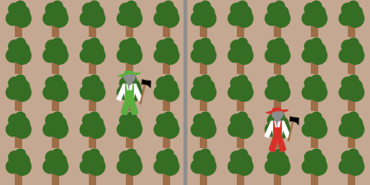
- The world now shows that it is full of trees. In addition, we see two little guys, and in this model, they represent foresters. In NetLogo models, these trees and foresters are called agents. This has nothing to do with secret agents or detectives. The word agent comes from the Latin word agere, which means something like to move, perform, act, react, affect. So agents can represent all sorts of things or organisms that move, behave or react to their environment in a certain way. So in this model, there are two agents that are represented as humans, and many other agents that are represented as trees. It does not really matter what the agents look like - except that it is easier for us to recognize and observe them in the model. What is more important is how they behave, how they react to their environment. We will see this soon.
- If you look closely, you can also see that the world is divided into two parts by a gray line. This means that the green forester only moves in his forest on the left side, and the red forester only moves in his forest on the right side.

Click One round a few times/Click Start
- This button one round lets the model run for one round. A round is also called an iteration. With the iteration counter up here, we can always read the current number of iterations. When we click on Setup again, the counter starts again from 0.

- The button Start lets the model run until you click the button again.
- The model speed can be slowed down and accelerated. For example, if we let the model run a little slower, we can observe agent behaviors and other things that happen in each round more closely; if we accelerate it, we can observe the outcomes over many iterations in a short time.
- Run the model for about 20 rounds (click one round or start – reduce model speed if needed)
- What happens in the world in each round/iteration? (Ask students and let them describe) The two foresters move around. When they leave a tree, it is smaller. That means they cut down some of the tree. The green forester takes less than the red forester. The trees grow slightly in each round, but only up to a certain height. That's the maximum height the trees can reach.
- Are the foresters moving around randomly? Not quite, they are looking for a tree in their immediate environment, which is the largest. If several trees are the same size, they just select one by chance. Then they go there and harvest from it.

Output Diagrams / output fields
- In these diagrams we can see some important variables about the world and the agents. (click Setup and Start again)
  - Forest Stock (% of maximum): This diagram shows us two curves: the green curve represents the state of the forest of the green forester. The red curve shows us the state of the forest of the red forester. The curve starts at 100%, because at the beginning of the model, all trees have the maximum height. When the simulation starts, the foresters start harvesting from the trees. So the stock in the forest decreases.
Why is the green curve different from the red curve?
The green forester harvests less of the trees than the red, so his stock of trees does not decrease as fast as the red forester's.
  - Harvest amount per iteration: this diagram shows us how much the two foresters harvested from a tree in each round. As we have already noticed, you can see that the red forester harvests more than the green forester. (after a few rounds, this will change, see below; Or ask right now: why)
  - Accumulated Harvest Amount: this chart shows us how much the two foresters collect in the course of the simulation.
Why is the green curve different from the red curve? The red forester harvests more in each round, so his cumulative crop increases faster than the green ranger. (after about 100 rounds, this will change, see below)
  - The variable values ​​of the graphs can also be read from the output fields next to the diagrams. We can also read the approximate values ​​with the cursors directly in the diagrams.

Exploring outcomes - setting Private forest
As a whole class discussion or with the help of a student worksheet assignment
- Long-term outcomes: If we continue to run the model with the existing settings (at least 200 iterations, slow down or accelerate model speed if necessary), we can observe what happens in the long term.
- Making predictions: What will happen in the longer term - to the two different forests and to the accumulated harvests of the two foresters? Let students predict and explain
- Click start and run the model
- What happens in the world? What do we see in the output charts? Let students describe and explain
  - Observation in the world: The red forester has almost completely harvested his forest. The green forester still has a lot of forest.
  - Output Diagrams: The forest of the red forester has only about 8% of its maximum growth. The forest of the green guy has about 73% of its maximum growth. The cumulative crop yield from the green forester is now higher than that of the red forester.
- How are the long-term results different from the short-term ones? Why?
In the short term, the red forester has gained more harvest than the green forester, but in the long run, he gets less than the green forester. The red forester harvests more of a tree each round than the green forester. So at the beginning, when all the trees are the same size, he achieves more harvest than the green forester. However, he harvests more than what regrows each round, so that his forest stock decreases more and more, while the forest of the green forester has enough time to grow back. As a result, the green forester has a consistently high tree harvest in each round in the long run, while the harvest of the red forester is low in the long term.
- How would you behave and manage your forest in this situation - more like the green forester, or more like the red forester? Why? (let students discuss and reflect on what humans generally, and what they themselves would do in this situation).
- In general, can benefits and other consequences of a behavior be different between the short-term and the long-term? What are some other examples of situations where this statement applies? let students draw conclusions by referring to the model. Other examples: eating cake (tastes good in the short term, bad for your health in the long-term); smoking; regular exercise (feels bad at the beginning, is good for you in the long-term); helping a friend with something (takes time and other costs in the short-term, but is good for friendship in the long-term); studying for an exam (takes time and is not so much fun in the short term, but better for success in the long-term)

Causal mapping
Let students create a causal map between resource availability, renewal rate, foresters' harvesting behavior, and accumulated harvest outcomes for them, in a private forest.
Possible extension assignments using the causal map:
- Let students connect the elements of the NetLogo model (parameters, output diagrams) to the factors in the causal map.
- Reading the causal map: let students use the causal map to predict what will happen to the system if they change one of the factors. Then let them use the NetLogo model to check their predictions and explain what they observe with the help of the causal map (or modify their causal map to match the observations in the model).

Materials:
- Causal mapping pieces
- Two foresters causal mapping JamBoard
- Two foresters causal mapping Google slides
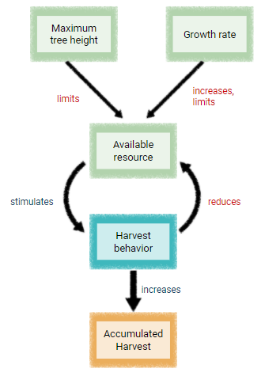
Possible result:

Exploring outcomes - Setting Common forest
As a whole class guided discussion or with the help of a student worksheet assignment
- With the switch Private-forest? we can determine whether the "fence" in the middle of the world should disappear, so that the foresters now share a single forest.
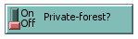
- What do you suppose will happen then? Will the long-term harvests for the green forester and the red forester be different than in the private forest setting? Why, or why not? let students discuss
- Click Setup and Start, and run (min. 200 iterations). What effects can we observe in the world and in the output charts?
The red forester always has more harvest over the long term than the green forester. He now has more forest available, because the green forester does not harvest so much and leaves more to him. So the red forester can harvest more, but at the expense of the green forester.
- How would you behave in this situation - more like the green forester, or more like the red forester? Why? What would you do in this situation if you were the Green Forester? (let students discuss and reflect on what humans generally, and what they themselves would do in this situation) Getting angry at the other, increase your own harvest, i.e. harvest just as much or even more than the red forester (as you do not want to be stupid, and watch another person gain an advantage at your own expense, it is unfair); or talking to one another, asking him to harvest less, pointing out that he is not behaving properly or that he is being mean, threatening him, convincing him, agree on a common harvest rate (making rules, negotiate)
→ possibly link to child dialogues in Children-Chimps resource sharing experiments
- Change parameter "Percent-cut" to reflect these situations, e.g.
  - both foresters harvest 90% if the green forester increases his harvest volume out of jealousy, anger or frustration (Start the model and let students describe what happens) → the result is the “Tragedy of the commons” - both deplete their common forest
  - both harvest 50% each, or 60% or 70% if they are able to agree on a harvest rate (Start the model and let students describe what happens)
- What would be the best for both of them to do in this situation?
It is best, if they could both agree on a harvest rate that both are happy with or find fair, and that allows them to harvest as much as possible in the long run without overusing the forest.

Causal mapping
Create a causal diagram between resource availability (commons), foresters' harvesting behavior, and outcomes for them as represented in the model.
Possible extension assignments using the causal map:
- Let students connect the elements of the NetLogo model (parameters, output diagrams) to the factors in the causal map.
- Reading the causal map: let students use the causal map to predict what will happen to the system if they change one of the factors. Then let them use the NetLogo model to check their predictions and explain what they observe with the help of the causal map (or modify their causal map to match the observations in the model).

Materials:
- Causal mapping pieces
- Two foresters causal mapping JamBoard
- Two foresters causal mapping Google slides

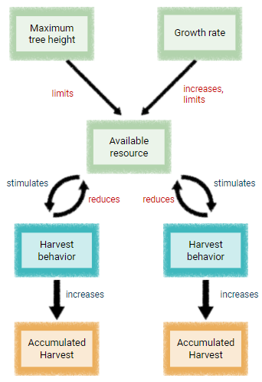
For example:

As a further extension and an opportunity to criticize the model, you may discuss the influence of other factors that are not represented in the model. For example, human emotions, social cognition, communication, making rules, etc.

How would human behaviors influence this dynamic? For example, what could be the role of emotions, observing the other’s behavior, and communication? How could we add them to the causal map?

Example:
Note: Emphasize to students that this is just one way to represent some of the possible causal interactions between factors that might be happening when two humans have to share a resource. When we try to represent the complex causal interactions between environment and human behaviors, there is often no single “right-or-wrong” answer, because we are dealing with complex phenomena. However, causal maps help us to identify, discuss and reflect on some important factors and their interactions. This is important if we want to understand real-world problems, and especially if we want to find ways to change certain factors in order to achieve better outcomes from these interactions.)

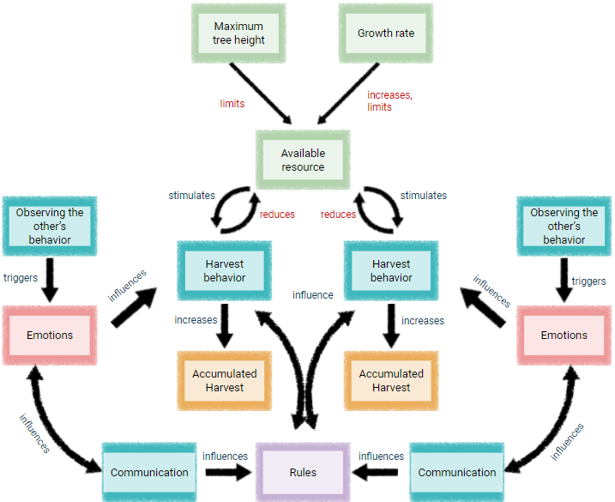

Changing model parameters and documenting experiments
- In the models, you can also change other parameters as a user
- First of all, we can see that we can set for each forester how much of a tree they should harvest. (see above)
- For the trees, we can set how fast they can regrow and up to which maximum height.
- → Let students "play around" with the parameters and observe the world and the output diagrams to see how the parameters affect the results.
- Students can run experiments (if possible, individual students or as groups of 2-4 students, otherwise with the whole class) with different parameter settings. See Worksheet assignment
- Example challenge: Which settings are best for both of them in the long-term? (For example, you can run a competition for students to find the settings that result in the highest accumulated harvest for both, e.g. over 300 iterations, under given growth rate and maximum tree height settings.)

Documenting experiments:
- Copy the World and Plots by right-clicking - copy image / copy view (nlogo)
- Export the whole interface to image file by clicking File - Export Interface (nlogo)
- Read variable values in diagrams using the cursor, and in output fields
Example of a table for documenting experiments:

Experiment 1 |  | Number of iterations: | 200
Parameter settings
Percent-cut1: | 75% | Maximum tree height: | 100
Percent-cut2: |  | Growth rate: | 0.1
Prediction/Hypothesis What do you predict or hypothesize will happen to the agent population and the resource under these settings?
Results
Accumulated harvest diagram Insert diagram of accumulated harvest here |  | Forest stock diagram Insert diagram of forest stock here
Description: Describe what the diagram of accumulated harvest shows |  | Description: Describe what the diagram of forest stock shows
Interpretation: Explain why you can observe these outcomes on accumulated harvest under the given parameter settings |  | Interpretation: Explain why you can observe these outcomes on the forest under the given parameter settings

Conducting Experiments and the Payoff Matrix
Let students represent outcomes of experiments, in terms of accumulated harvest for each forester in a payoff matrix. (fill out the payoff matrix for one model simulation with the whole class so that students understand the process)
Payoff matrix worksheet

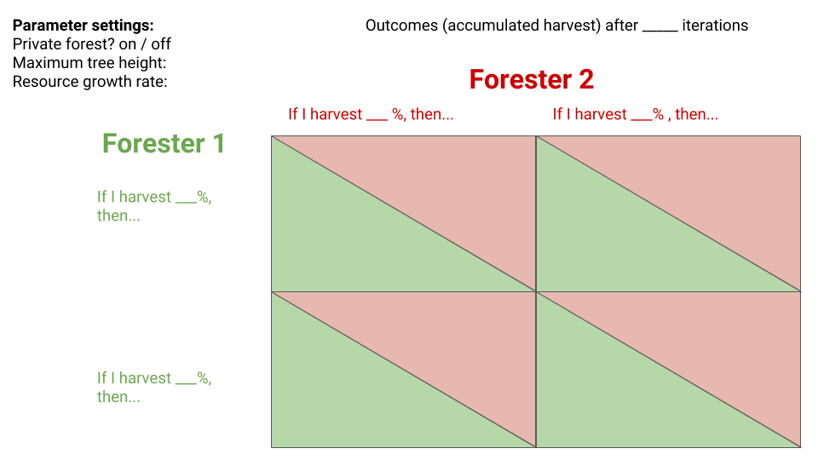
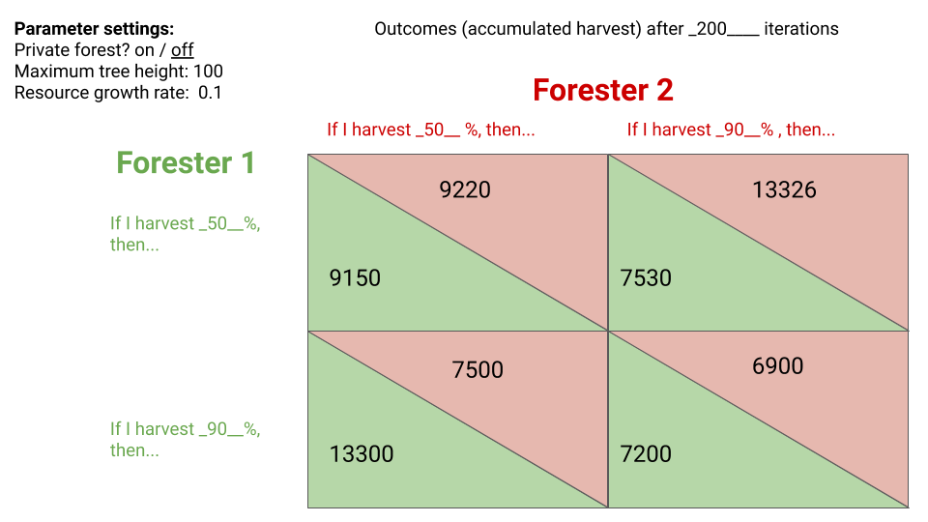
Example:

Reflection on the concept of social dilemma:
Situations in which people behave in a way that benefits themselves but harms the whole group, or in a way that has beneficial outcomes for them in the short-term, and negative outcomes for everyone in the long-term, is called a social dilemma.

Describe how the situation of the common forest use is a social dilemma, by referring to the outcomes you entered in the payoff matrix.
The situation of the common forest use in the model is a social dilemma, because each of the individual foresters get the most harvest if they harvest a lot, while the other harvests little. This motivates both of them to harvest a lot. However, if both harvest a lot, then they both get the least (the bottom right corner of the payoff matrix), compared to if they both harvest a little at a time (the top left corner of the payoff matrix).

Analogy Table: Recognizing and comparing model properties with the real world
Models are simplifications of the real world. They represent some aspects of the real world but leave out others. Which aspects of the real world does the Two foresters model represent, and which ones does it leave out?
See Worksheet assignment

Discuss and mark in the table below, whether the following processes, principles, conditions, or behaviors apply to all living things, and whether they are simulated in this model. Set a question mark or make notes if you are not sure.
Tip: If you are not sure whether something is represented in the model, look at the model description in the Model info tab or in the overview page and watch the model simulations.
Note to teacher: Some conditions can apply only sometimes or only for certain living beings. We can also narrow the analogy table down by asking whether a condition/behavior applies to all animals, or all mammals, or to all humans, or to us personally.
Processes / principles / conditions /  behaviors | applies to all living beings? | represented in the model?
Living beings / agents remove resources/energy from their environment.
Resources in the world are limited.
Living beings / agents need resources / energy to survive.
Living beings / agents use up energy to get resources/energy.
Living beings / agents can produce offspring with similar characteristics.
Living beings / agents vary in their characteristics / behaviors.
Living beings / agents are moving around in the world.
Living beings / agents move towards favorable / advantageous conditions.
Living beings / agents die if there is insufficient energy intake.

Discuss which other processes, behaviors, conditions or principles apply to the biological world or to certain living beings (e.g. humans) or ecosystems and to what extent they are represented in this model.
What processes, conditions or behaviors would you want to add or change in the model to see what happens to the agents and the world? → Informatics
For example: often groups of living beings are much bigger than two; often living beings don’t move around in the whole “world” but just in a part of it; living beings can adjust their behavior in response to the environment; many living beings/humans can notice the behavior of others and react to it, can communicate with others; humans have emotions, humans have technologies that can change their harvest behavior, or that can change parameters of the resource (e.g. carrying capacity, renewal rate), etc.

Possible solution
Note to teacher: Some conditions can apply only sometimes or only for certain living beings. We can also narrow the analogy table down by asking whether a condition/behavior applies to all animals, or all mammals, or to all humans, or to us personally.
Processes / principles / conditions /  behaviors | applies to all living beings? | represented in the model?
Living beings / agents remove resources/energy from their environment. | x | x
Resources in the world are limited. | (x) | x
Living beings / agents need resources / energy to survive. | x
Living beings / agents use up energy to get resources/energy. | x
Living beings / agents can produce offspring with similar characteristics. | x
Living beings / agents vary in their characteristics / behaviors. | x | x
Living beings / agents are moving around in the world. | (x)? | x
Living beings / agents move towards favorable / advantageous conditions. | (x)? | x
Living beings / agents die if there is insufficient energy intake. | x

Reflection on conceptual understanding
See Worksheet assignment

Students write a short essay answering all or a subset of the following questions (depending on the focus of the lesson or unit), using evidence from the computer simulation and insights from the discussion, and possibly relating to examples of real-world situations.
- What problems can arise when a group of people have to share a common resource?
- How can conditions and behaviors influence the development of a shared resource? For example, what can be the influence of human emotions and communication?
- Can benefits and other consequences of a behavior be different between the short-term and the long-term?
- Why might sustainability scientists use computer simulations to better understand how conditions, behaviors, and other factors affect the sustainable development of social-ecological systems?
- Why might sustainability scientists use causal maps to better understand how conditions, behaviors, and other factors affect the sustainable development of social-ecological systems?
- Why might sustainability scientists use payoff matrices to better understand the motivations and outcomes of people’s behavior in certain situations?

References
Wilensky, U. (1999). NetLogo. Center for Connected Learning and Computer-Based Modeling, Northwestern University. http://ccl.northwestern.edu/netlogo.

Author: Susan Hanisch susan.hanisch@eva.mpg.de

If you would like to use this material in your classroom, we would be happy if you contact us. For more information and teaching materials, visit our website:

http://openevo.eva.mpg.de

This material was developed in collaboration with the department of Comparative Cultural Psychology at the Max Planck Institute for Evolutionary Anthropology and the biology education working group of Friedrich Schiller University Jena.



https://www.eva.mpg.de/comparative-cultural-psychology/research-areas/education-innovation/

With partial funding by the Joachim Herz Foundation

This work is licenced under a Creative Commons Attribution-NonCommercial-ShareAlike 4.0 International (CC BY-NC-SA 4.0) licence.

